**Hotel Management System Overhaul**



***Use Case Specification Document***

**Hotel Administration**

**Version No. 1**

**Project Document Revision History**

|  |  |  |  |
| --- | --- | --- | --- |
| **VersionNumber** | **Date** | **Revision Author** | **Description of Revision** |
| 1 | 6/25/20 | Peter Schubert | Initial Version |
|  |  |  |  |

|  |
| --- |
| **Table of Contents** |

**Introduction** **3**

**Use Case Information** **4**

Actors 4

Use Case Interaction 4

**Trigger** **5**

**Pre-condition(s)** **5**

**Post-condition(s)** **5**

**Use Case Swimlane (Activity) Diagram** **5**

**Main/Basic Flow(s) of Events (Happy Path)** **6**

**Alternate/Exception Flow of Events** **7**

**Assumptions/Business Rules including Non-Functional Requirements** **7**

**Use Case Specification Review and Signoff** **7**

# **Introduction**

This document captures detailed functional and non-functional BUSINESS requirements. Technical or application IT requirements should not be detailed here. A separate Use Case Summary document ties ALL the individual use cases together. First create the Use Case Summary document using application decomposition. Then increase the detail by creating the individual use case specifications – be careful not to create too many or not create enough use cases.

Employees have to be able to login via Access Hotel System using the correct username and password. For managing the hotel rooms and Hotel locations, Employee checks on the availability of and unavailability of rooms in a hotel, cannot change availability unless for maintenance after room becomes available. Employees are able to set the cost (monetary and in points) of the rooms and maximum capacity per room: Points per type of room, Quantity of beds in each room, Price Changes are logged. Finally the Employee will have the ability to generate summary reports of hotel metrics: Frequency/most visited customers, occupancy:The average number of occupied rooms per a given day, Popular hotel rooms, Total employee pay / expenses, and Revenue of the reservations

# **Use Case Information**

## **Actors**

An actor is someone or something (e.g. application system) outside the system or business that interacts with the application. For every Use Case, there must be at least one Main Actor and zero or more Secondary Actors. Actors should be a person, system, or time.

|  |  |  |
| --- | --- | --- |
| Actor Name | Role | Description |
| Employee | Main | Primary Actor: interacts with system to cancel and review reservations, create accounts for customers, view summary reports and hotel informatics, and manage the hotel and various functions |
| System | Secondary | Secondary Actor: interacts with the system to store the necessary data about the customer, employees, hotel, and reservation. |
| Hotel Management System | Secondary | Interacts with the system to store, collect, or manipulate data within the system’s data stores and present back to the Customers and Employees |

## **Use Case Interaction**

How does this use case relate to other use cases? List predecessor and successor use cases.

**Successor Use Cases**

* N/A

**Predecessor use Cases**

* Access Hotel System
  + Employee needs to login in order to manage the necessary functions of the hotel

# **Trigger**

* Employees enters into the system then selects to view and /or manage physical details about the hotel or parts of the hotel

# **Pre-condition(s)**

What use cases or other pre-conditions must be met before use can initiate?

## The Employee must be successfully able to access the hotel management system (via Access Hotel System use case)

## System must be fully configured with information about each hotel

* + 1. There must be appropriate hotels, hotel rooms, and hotel events for each location, and each location must be valid

# **Post-condition(s)**

What are ALL the possible output states upon completion of the use case flows?

## The status of a particular hotel and or hotel rooms is changed successfully

* + 1. **Room status changed from available to under maintenance or vice versa**

## Successfully managing the details of the room and/ or events

## The cost of the room or event is modified to lowered or increased

## The points awarded to the type of each room are changed

## The maximum capacity per room and the number of rooms

* 1. **An analytics report is generated containing details and informatics of the the hotel**
     1. **Information about hotel expenses, revenue, most visited customers, room occupancy rates, and popular hotel rooms are listed in a report**

# **Use Case Swimlane (Activity) Diagram**

Draw diagram(s) that cover ALL main and alternate flows.

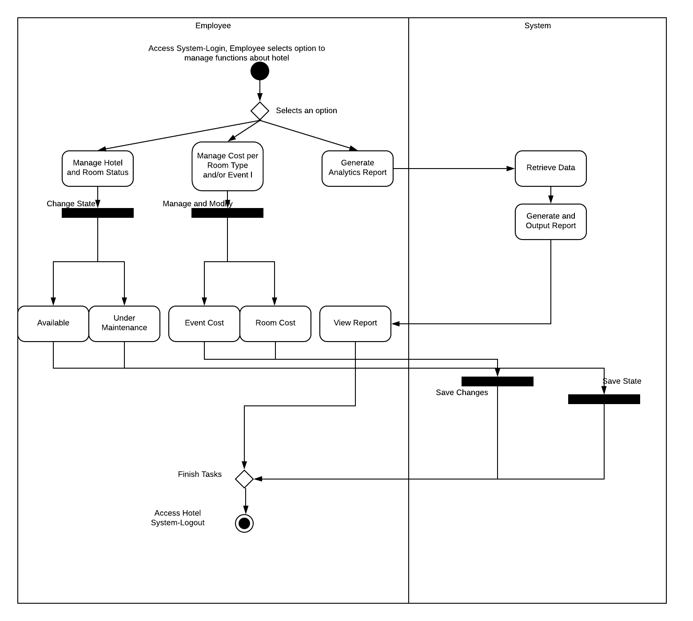

# **Main/Basic Flow(s) of Events (Happy Path)**

For each main flow (usually ONE flow) write the list of steps that occur – describe WHAT occurs not HOW to do it!

## Manage Hotel and Room Status

* + 1. The employee selects to manage the hotel and/or room status
    2. Selects a hotel or a room of a hotel and changes the state from:
       1. Available to Under Maintenance
       2. Under Maintenance to Available
    3. The state of the room is saved to the system

## Manage Cost Per Room and Events

* + 1. Employee selects to manage the cost (monetary and/or points) of a hotel product or service
    2. Chooses and modifies the cost of a type of room, event, or package
    3. System saves the changes to the costs
  1. **Generate Summary Reports**
     1. Employee selects to generate a summary report for the hotel system
     2. The system retrieves the necessary data for the report
     3. Report is generated and output by the system as a file
     4. Employee Views the Report

# **Alternate/Exception Flow of Events**

For each alternative flow (can be zero or more) write the list of steps that occur – describe WHAT occurs not HOW to do it!

**N/A**

# **Assumptions/Business Rules including Non-Functional Requirements**

Be sure to number the assumption/business rules to allow easy reference to them. Business rules will be where non-functional requirements are recorded – have a way to specifically identify non-functional requirements.

**N/A**

# **Use Case Specification Review and Signoff**

|  |  |  |  |  |
| --- | --- | --- | --- | --- |
| Review and Signoff of the Use Case Specification | | | | |
| Name | Project Team Role | Signature | Date | |
| Peter Schubert | Team Lead/ Software Developer | PS | 6/26/20 | |
| Jeffrey Fishman | Software Developer | JF | 6/26/20 | |
| Monier Abdullah | Software Developer | MA | 6/26/20 | |
| Khalid Saeed | Software Developer | KS | 6/27/20 | |